**BANK LOAN REPORT (SQL Query Documentations)**

**DASHBOARD 1 : SUMMARY**

**KPI’s**

1. Total Loan Applications

**select count(ID) as Total_Applications from bank_loan_db;**



1. MTD Loan Applications (Month to Date)

**SELECT COUNT(ID) AS Total_Applications FROM bank_loan_db WHERE EXTRACT(MONTH FROM issue_date) = 12 AND EXTRACT(YEAR FROM issue_date) = 2021;**



1. Previous Month Loan Applications (Month to Date)

**SELECT COUNT(ID) AS PMTP_Total_Applications FROM bank_loan_db WHERE EXTRACT(MONTH FROM issue_date) = 11 AND EXTRACT(YEAR FROM issue_date) = 2021;**



1. Total Funded Amount

**select sum(loan_amount) as Total_Funded_Amount from bank_loan_db;**



1. Month to Date Total Funded Amount

**select sum(loan_amount) as MTD_Total_Funded_Amount from bank_loan_db WHERE EXTRACT(MONTH FROM issue_date) = 12 AND EXTRACT(YEAR FROM issue_date) = 2021;**



1. Previous Month to Date Total Funded Amount

**select sum(loan_amount) as PMTD_Total_Funded_Amount from bank_loan_db WHERE EXTRACT(MONTH FROM issue_date) = 11 AND EXTRACT(YEAR FROM issue_date) = 2021;**



1. Total Payment Received

**select sum(TOTAL_PAYMENT) as Toatl_Amount_Received from bank_loan_db;**



1. Total Payment Received MTD

**select sum(TOTAL_PAYMENT) as Toatl_Amount_Received from bank_loan_db WHERE EXTRACT(MONTH FROM issue_date) = 11 AND EXTRACT(YEAR FROM issue_date) = 2021;**



1. Total Payment Received PMTD

**select sum(TOTAL_PAYMENT) as PMTD_Toatl_Amount_Received from bank_loan_db WHERE EXTRACT(MONTH FROM issue_date) = 11 AND EXTRACT(YEAR FROM issue_date) = 2021;**



1. Average Interest Rate

**select round(avg(int_rate) *100,2) as AVG_INT_RATE from bank_loan_db;**



1. Average Interest Rate MTD

**select round(avg(int_rate) *100,2) as AVG_INT_RATE from bank_loan_db WHERE EXTRACT(MONTH FROM issue_date) = 12 AND EXTRACT(YEAR FROM issue_date) = 2021;**



1. Average Interest Rate PMTD

**select round(avg(int_rate) *100,2) as AVG_INT_RATE from bank_loan_db WHERE EXTRACT(MONTH FROM issue_date) = 11 AND EXTRACT(YEAR FROM issue_date) = 2021;**



1. Average Debt-to-income Ratio (DTI)

**select round(avg(dti)*100,2 ) as AVG_DTI_RATIO from bank_loan_db;**



1. Average Debt-to-income Ratio (DTI) MTD

**select round(avg(dti)*100,2 ) as MTD_AVG_DTI_RATIO from bank_loan_db WHERE EXTRACT(MONTH FROM issue_date) = 12 AND EXTRACT(YEAR FROM issue_date) = 2021;**



1. Average Debt-to-income Ratio (DTI) PMTD

**select round(avg(dti)*100,2 ) as PMTD_AVG_DTI_RATIO from bank_loan_db WHERE EXTRACT(MONTH FROM issue_date) = 11 AND EXTRACT(YEAR FROM issue_date) = 2021;**



**Good Loan v Bad Loan KPI’s**

**Good Loan**

1. Good Loan Application Percentage

**SELECT**

**ROUND(**

**(SUM(CASE WHEN loan_status IN ('Fully Paid', 'Current') THEN 1 ELSE 0 END) * 100.0)**

**/ COUNT(id),**

**2**

**) AS Good_Loan_Percentage**

**FROM bank_loan_db;**



1. Good loan Application

**select count(id) as Good_Loan_Application from bank_loan_db where loan_status in ('Fully Paid','Current');**



1. Good Loan Funded Amount

**select sum(loan_amount) as Good_Loan_Funded_Amount from bank_loan_db where loan_status in ('Fully Paid','Current');**



1. Good Loan Total Received amount

**select sum(total_payment) as Good_Loan_Received_Amount from bank_loan_db where loan_status in ('Fully Paid','Current');**



**Bad_Loan**

1. Good Loan Application Percentage

**SELECT**

**ROUND(**

**(SUM(CASE WHEN loan_status ='Charged Off' THEN 1 ELSE 0 END) * 100.0)**

**/ COUNT(id),**

**2**

**) AS Bad_Loan_Percentage**

**FROM bank_loan_db;**



1. Bad loan Application

**select count(id) as Bad_Loan_Application from bank_loan_db where loan_status = 'Charged Off';**



1. Bad Loan Funded Amount

**select sum(loan_amount) as Bad_Loan_Funded_Amount from bank_loan_db where loan_status = 'Charged Off';**



1. Good Loan Total Received amount

**select sum(total_payment) as Bad_Loan_Received_Amount from bank_loan_db where loan_status = 'Charged Off';**



**Loan Status**

**select**

**loan_status,**

**count(id) as Loan_Application,**

**sum(total_payment) as Total_Amount_Received,**

**sum(Loan_Amount) as Total_Funded_Amount,**

**round(avg(int_rate *100),2) as Intrest_Rate,**

**round(avg(dti * 100),2) as DTI**

**from**

**bank_loan_db**

**group by loan_status;**

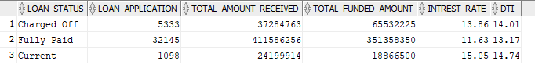

**Current Month**

**select loan_status,**

**sum(total_payment) as MTD_Total_Amount_Received,**

**sum(loan_amount) as MTD_Total_Funded_Amount**

**from bank_loan_db WHERE EXTRACT(MONTH FROM issue_date) = 12 group by loan_status;**

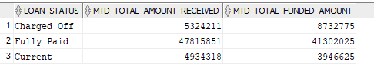

**DASHBOARD 2 : OVERVIEW**

1. Monthly Trend by Issue Date

**SELECT**

**EXTRACT(MONTH FROM issue_date) AS Month_Number,**

**TO_CHAR(issue_date, 'Month') AS Month_Name,**

**COUNT(id) AS Total_Loan_Application,**

**SUM(loan_amount) AS Total_Funded_Amount,**

**SUM(total_payment) AS Total_Received_Amount**

**FROM bank_loan_db**

**GROUP BY**

**EXTRACT(MONTH FROM issue_date),**

**TO_CHAR(issue_date, 'Month')**

**ORDER BY**

**EXTRACT(MONTH FROM issue_date);**

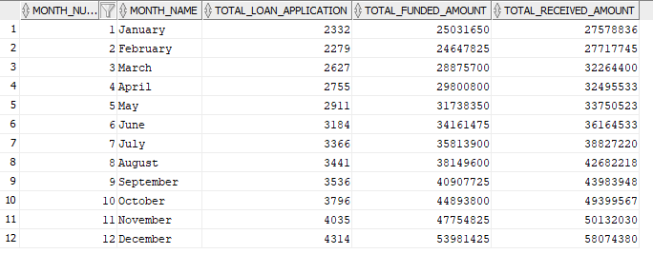

1. Regional Analysis by State

**SELECT**

**address_state,**

**COUNT(id) AS Total_Loan_Application,**

**SUM(loan_amount) AS Total_Funded_Amount,**

**SUM(total_payment) AS Total_Received_Amount**

**FROM bank_loan_db**

**GROUP BY address_state order by count(id) desc;**

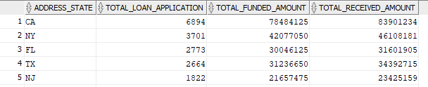

1. Loan Term Analysis

**SELECT**

**term,**

**COUNT(id) AS Total_Loan_Application,**

**SUM(loan_amount) AS Total_Funded_Amount,**

**SUM(total_payment) AS Total_Received_Amount**

**FROM bank_loan_db**

**GROUP BY term order by term;**

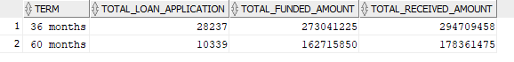

1. Employee Length Analysis

**SELECT**

**emp_length,**

**COUNT(id) AS Total_Loan_Application,**

**SUM(loan_amount) AS Total_Funded_Amount,**

**SUM(total_payment) AS Total_Received_Amount**

**FROM bank_loan_db**

**GROUP BY emp_length order by COUNT(id) desc;**

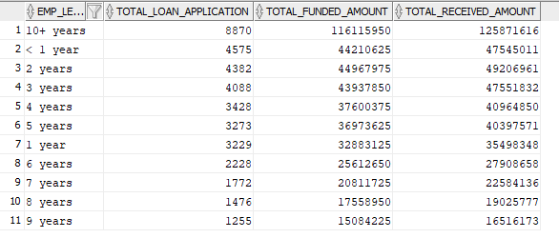

1. Loan Purpose Breakdown

**SELECT**

**purpose,**

**COUNT(id) AS Total_Loan_Application,**

**SUM(loan_amount) AS Total_Funded_Amount,**

**SUM(total_payment) AS Total_Received_Amount**

**FROM bank_loan_db**

**GROUP BY purpose order by COUNT(id) desc;**

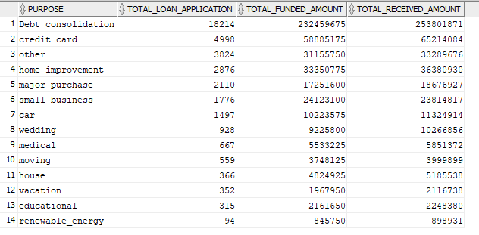

1. Home Ownership analysis

**SELECT**

**home_ownership,**

**COUNT(id) AS Total_Loan_Application,**

**SUM(loan_amount) AS Total_Funded_Amount,**

**SUM(total_payment) AS Total_Received_Amount**

**FROM bank_loan_db**

**GROUP BY home_ownership order by COUNT(id) desc;**

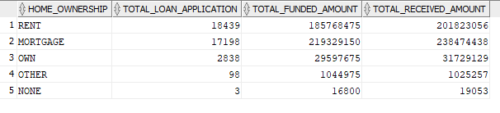

**DASHBOARD 3 : DETAILED**

**Gird View**

**Select *from bank_loan_db;**